EPU & TPU Screen Protector

Electroplate AF Coating Series



HD

EPU HD

180。


Privacy

EPU 180°
Anti-spy Privacy

N
N
I
W
E
N
★
★
★
★
★
★
★
★
N
O
I
T
A
V
O
360。

Privacy
EPU 360°
Anti-spy Privacy

TPU(0.15mm)
TPU HD 0.15mm


TPU(0.2mm)
TPU HD 0.2mm



TPU(0.25mm)
TPU HD 0.25mm




AG
EPU Anti-glare Matte

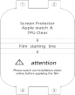
TPU Watch film


UV Series Privacy Series

AR UV
SCREEN PROTECTOR
AR UV | 5H  5H HARDNESS FULL COVER ANTI-GLARE ANTI-SCRATCH
AR UV |  | START TO INSTALL FILM  AR UV |  | 用酒精包里的定位贴  粘贴撕掉此面膜后再烤灯  UV

粘贴撕掉此面膜后再烤灯
Film starting line
用酒精包里的定位贴

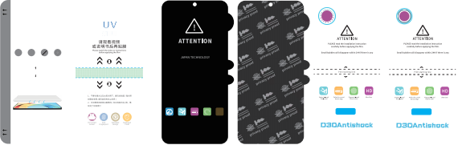  180。 |  |  |  |  |  | N  N  I  W  I  T  A  V  O  E  N  ★  ★  N  O  ★  ★  ★  ★  ★  ★  360。
AUTO-REPAIR EPU

360° PRIVACY
<30°  Less than 30 Privacy angle | Explosion-proof Drop-proof | Perfect for curved Narrow edge | Fingerprint-proof Easy to clean | Scratch proof | Privacy | Privacy
EPU 360° | TPU 35° | EPU 180° | EPU 360°
Anti-spy Privacy | Anti-spy Privacy | Anti-spy Privacy | Anti-spy Privacy

More Cutting Films

  HD  Small bubbles will disappear within 24 H if there is any |   MATT  Small bubbles will disappear within 24 H if there is any |   Blue light  Small bubbles will disappear within 24 H if there is any | HD
TPU HD | TPU Anti-glare Matte | Blue Light | EPUAnti-shock


Shenzhen AFS Technology Co.,Ltd
Attn: amykuang Mob:+86 135 4414 6351 E-mail:amykuang@gdafs.com
Factory address: 3rd floor, No.24 Houting 4th Industrial Area, Shajing, Bao'an District, Shenzhen, China Mainland.

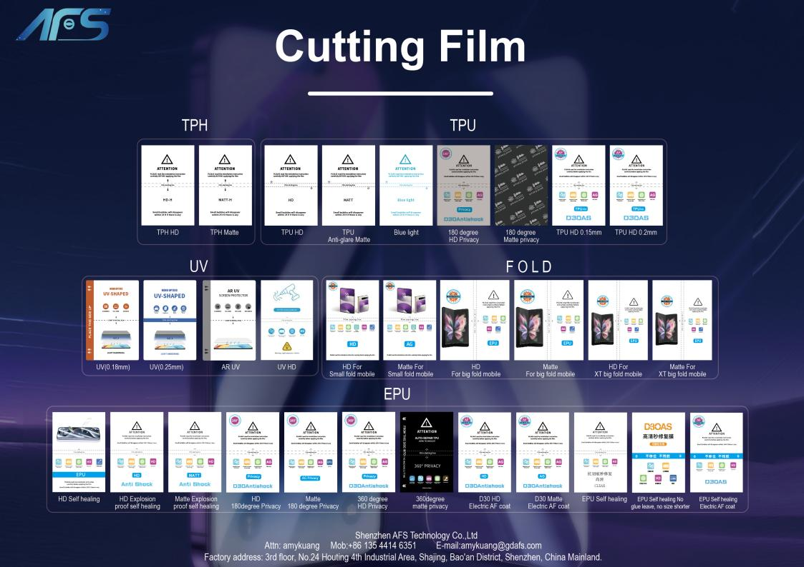

HD & Matte Back Film









ntist Desig
nti
rp
nti
erp
nti
rp
A
A Fi nge
Ant
De
A Fi ng
Ant
De
A Fi nge
rved
e n
rved
e n
d
Fit Cu scre
Fit Cu scre
Fit Cu scre
ExP
P
ExP
P
ExP
P
a
a
a
rv
e

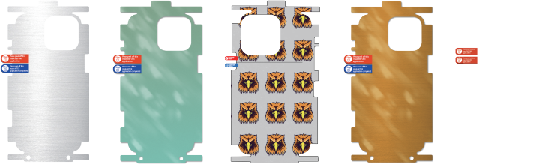

Shenzhen AFS Technology Co.,Ltd
Attn: amykuang Mob:+86 135 4414 6351 E-mail:amykuang@gdafs.com
Factory address: 3rd floor, No.24 Houting 4th Industrial Area, Shajing, Bao'an District, Shenzhen, China Mainland.

Fold Mobile Screen Protector

shenzhen AFS Technology co., Ltd

Fold Mobile Screen Protectors Factory

Product Structure Diﬀerent Material

HD Clear
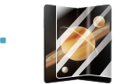
1

2
FOLDABLE SCREEN PROTECTOR
Tips: It is better to rest for 5-10 minutes after pasting and then fold
For Magic V3=VS3
3
A

B
Anti glare Matte
Anti-spy privacy
C

D

A Protective ﬁlm B EPU screen protector

C Position layer D Release ﬁlm

Product Features Diﬀerent Install Way

• With AF coating, 115°water angle
No installation tray
With easy
installation tray
• No left for big curved screen
• Anti impact
FOLDABLE SCREEN PROTECTOR
for 5- 10 minutes
FOLDABLE SCREEN PROTECTOR
for 5- 10 minutes
then fold
For HUAWEI Mate X6
• Spring back quickly
then fold
It is better to rest
after pasting and
For HUAWEI Mate X6
rest
and
Tips: It is better to
after pasting
• No glue left
Tips:
• Suitable for screens of any shape
1
2
3

